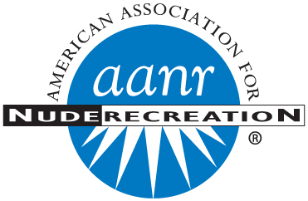

American Association for Nude Recreation

1703 N. Main Street, Suite E ▪ Kissimmee, Florida 34744

800-TRY-NUDE ▪ 407-933-2064 ▪ Fax 407-933-7577

try-nude@aanr.com ▪ www.aanr.com

To: AANR Officers, Trustees, Committees, Clubs, and Members

From: Erich E. Schuttauf, Esq. Executive Director

Date: January 31, 2023.

Re: AANR Executive Director’s Report to AANR 2023 Midwinter Meeting of the Board of Trustees

I deeply appreciate the opportunity to join AANR’s leadership, members, and clubs at Lake Como Resort in Lutz, Florida for this meeting. We appreciate the work of Como’s volunteers and staff which has made this possible. Here is a report detailing major developments in 2022 and some initiatives coming in 2023.

A “Change of Heart” – Thank you for the cards and good wishes that so many within the AANR community extended to me during my recovery from unexpected open heart surgery during the Christmas / New Year holiday. These were a big help in keeping my spirits up and I am happily on the mend.

*Hurricanes, Hurricanes, and Floods!* - Following the AANR convention, the fall 2022 season brought two major hurricanes to the Caribbean, and the state of Florida, before moving North as far as Georgia, the Carolinas, even Canada. (Prior to that, Hurricane Fiona hit the Caribbean as well.) Hurricane Ian struck the Florida coast on September 28th. Then, in November Hurricane Nicole struck… unusual for so late in the year. We regret to report that some AANR members lost lives during Ian and all AANR Florida clubs sustained varying amounts of damage. The AANR headquarters was threatened by heavy flooding in the area, yet sandbags helped to avert this. The impact on future insurance rates is sure to be felt for some time.

On the West Coast, we are mindful of the many clubs which have sustained heavy, heavy rains over the past few months. Laguna del Sol of Wilton, CA and the Sequoians of Castro Valley, CA are among those sharply feeling the effects of this weather. Club and Member Weekly Reports have carried links to news coverage.

*Wreaths Across America Success and* *Thanks* – This year, with special thanks to BG Parkes and Suwannee Valley Resort, AANR worked with Wreaths Across America to honor veterans. For each wreath that AANR members helped sponsor, the Association received five dollars. Donors have been gratefully acknowledged in copies of *The Bulletin.*

*Plan to Attend AANR 2023 Convention at Solair Recreation League in Woodstock, Connecticut!*

Solair has a rich New England Heritage and is located in a beautiful setting which has been a favorite of generations too. Convention takes place August 7 - 12, 2023.

*Magazine Story in Document Journal Highlights Pasco County Clubs and Resorts* - https://www.documentjournal.com/2022/12/in-pasco-county-florida-nudist-capital-usa-the-body-politic-is-on-fully-display/

This story was made possible through the hard work of many people and clubs within the AANR Florida region. I will present some images collected in the photo essay section of the story during my Executive Director session.

*Bulletin Postage Offset*

A significant challenge continues to be escalating prices of such services as printing, postage, and mail house delivery of *The Bulletin* in hard copy form. With renewals that begin in April, 2023 AANR will implement a surcharge to offset postage. There is *no* additional charge for the electronic version of The Bulletin. Premier members will receive complimentary postal delivery. Those who have purchased two or three year memberships will not be assessed the charge until future renewal.

*AANR Receives Generous Planned Gift from the Trust of John and BJ Kinman*

The Association is grateful to the late John and BJ Kinman, who made a thoughtful provision in the family’s trust. John served as a President of AANR and leader in two regions… the AANR West and Northwest. His wife BJ was always at his side promoting nude recreation, and also adding a dose of optimism and creativity to any event or project.

The Kinman family’s gift was received in late 2022 after both passed away. A thank you note signed by AANR leadership was sent to acknowledge this with appreciation. If you wish to receive information about AANR’s Partners in Planned Giving program, please call the office at 1-800-879-6833, or pick up material during this weekend’s meeting.

*Health and Wellness Calling Project.*

Beginning in Winter 2020, in response to health and travel conditions and at the suggestion of Past President Kathy Watzel, AANR staff began telephoning (and where applicable sending follow-up emails) to Direct members of the association who had not renewed after being sent the customary notices by mail (i.e. after more than two months). AANR staff continues to make these member communications and track them. *More than 6,600 communications*, record updates, and member renewal discussions have taken place since this project began.

*Member Zoom Sessions*

These continue on alternating Thursday evenings online. Thanks to Trustee Karen Lahey, Ronna Krozy, Past Trustee Walt Stevens, and many, many volunteers. Groups sharing multiple interests, as well as rooms dedicated to government affairs are part of the program, as are door prize offerings.

**Government Affairs and Legal**

*National Conference of State Legislatures (NCSL) Denver.*

As you know, AANR wrapped up a very successful attendance at the NCSL in Denver, Colorado, held in early August 2022. The theme for the year’s souvenir pin was “Dare to Be Bare” and featured the signature Blue Bear mascot of the Denver Convention Center. These were an instant hit with lawmakers and staff.

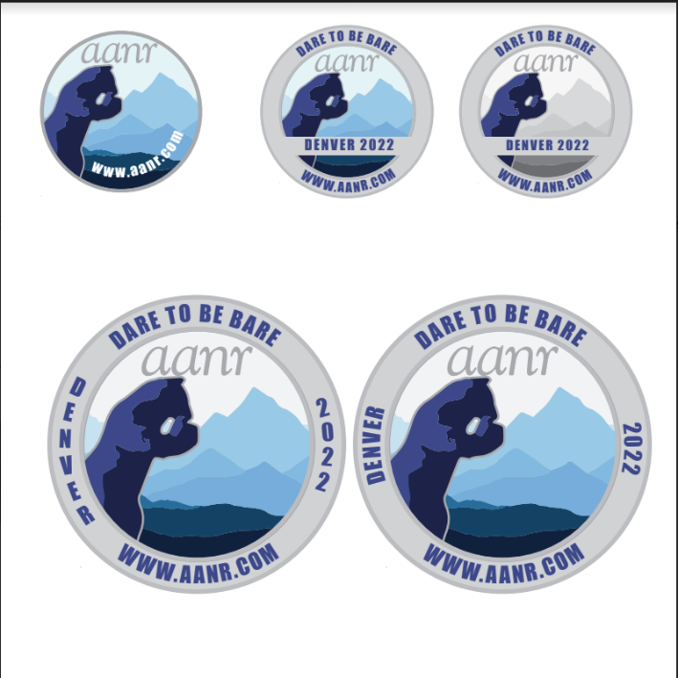 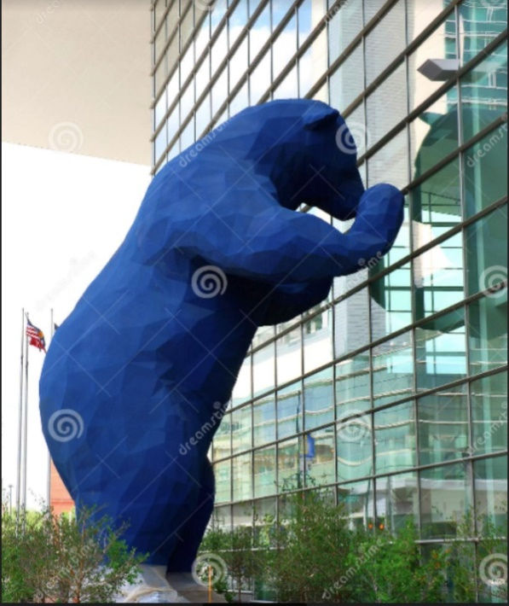

*NCSL Scheduled in Indianapolis Next Summer.*

AANR will return to Indianapolis, Indiana for this conference. The Association staffed its booth there in 1999 and was scheduled to be there a few years ago when NCSL was canceled due to the pandemic. Souvenir pins had already been created for the event featuring the aanr.com web address on a blue roadster driven by a topless driver and was popular with those who claimed one at other shows.. This year repeats the theme with red colors.

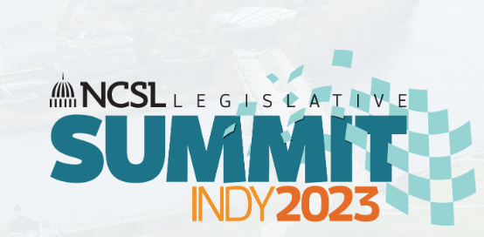 

*New StateNet Service and Canadian Pulse Service*

AANR’s Government Affairs Team tracks 50 state legislation plus Puerto Rico, the Canadian provinces, and some regulatory bulletins through software subscriptions. This allows Association volunteers and staff to spot trends. This year, AANR added StateNet for US developments as a tracking tool in addition to the Pulse service in Canada. I wish to personally thank Bob Morton, John Hunter, and Tim Mullins for substantial work setting up these tools.

*AANR Helping Members and Clubs.*

As also occurs from year to year, AANR received a significant number of requests for information and assistance related to citations received for nudity.

Here are some of the specific actions over the past six months. Names and identifying information are redacted for confidentiality reasons. Note that many situations require follow-up over several weeks or months; issues where a new jurisdiction becomes involved (e.g. from criminal to civil court) are given a separate entry below:

January 2022

* Monitored developments in a federal lawsuit filed in California by the famed skinny-dipping baby who appeared on the cover of the rock band Nirvana’s album Nevermind thirty years ago. AANR and I reviewed the complaint, amended complaint, and additional pleadings in the suit, which seeks damages based on pornography laws. AANR also offered expertise as the filer of amicus curiae briefs on related subjects going back to the 1950s.
* AANR assisted a nudist in the Southwest who was sanctioned by their homeowner association (HOA) for sunbathing in skimpy swimwear when / where they could be observed by others. Meanwhile, another nudist had challenges with neighbors over night-time skinny dipping and security cameras present. In addition to providing general guidance to both individuals, I subsequently wrote an article for The Bulletin about dealing with neighbor disputes, including HOA issues.
* Reviewed and tracked a bill in the Midwest concerning consent to have images including nudity taken and circumstances when permission may be revoked.

* Provided guidance to a member and guest of a nudist club who received the ire of a delivery driver making a restaurant drop-off.

* Addressed questions related to nudity at “Airbnb” bed and breakfasts.
* Carolyn and I explained various precedents and statutes relating to the legitimacy of family nudism to an east coast attorney representing nudists in a custody proceeding.

* Carolyn and I also prepared to present expert testimony on the subject during a court zoom session. Three days before the hearing was scheduled, we received word that the opposing party had dropped the nudity issue completely in light of the material that had been planned for introduction. Case settled!

* Fielded calls related to the propriety and suggested guidance for dealing with photography within common nude areas within a club.

* Preparations in proceedings to be brought with Florida’s Department of Environmental Protection (DEP) regarding nudity in state parks and conservation areas.

* Fielded calls and questions and provided some basics about events/activities occurring in the club, which has not held an AANR charter for more than ten years.

February 2022

* Provided basic guidance to a nudist facing eviction from residence.

* Detailed conversations with club officer planning series of nude volleyball events, as well as leasing facility and conducting nude activities for families within locations that may be licensed to sell/serve alcohol.
* Reached out to the regional offices of the American Civil Liberties Union (ACLU) to advise and warn of bills AANR and regions were tracking that would modify the obscenity standards on computer systems used by libraries, including school facilities. Contacted some AANR members to obtain their assistance in stopping pending bill(s) as well.

* Addressed questions from an AANR member about enforcing warranty and condition representations made related to an RV purchase and service.

* Reviewed the propriety of select advertising for a nudist club per principles and standards.

* Reviewed communications apprising AANR of possible obscenity charge(s) pending.

* Provided assistance to a member whose image was taken and published to discredit them in candidacy for a local political office.

* Provided assistance to another member whose image was taken and published to discredit them (the case occurred in a different location with a different person(s) involved than in the entry that appears immediately above).

* Provided background on Florida’s indecent exposure law (e.g. 800.03) to a club certifying officer within the state.

March 2022

* Provided guidance to committee volunteers regarding conduct/procedures used online in Meet and Greet sessions.

* Provided guidance during an ongoing dispute among several club members, directing various accusations. Discussed legal implications of same.

* Question and answer session with a club’s leadership concerning various aspects of youth/family programming at the club.

* Provided guidance to a nudist lady who experienced increasing hostility from her condominium owners association after her nudist affiliation became known following a leak of that information by a relative.

* Fielded questions seeking guidance for handling a club staff member with a website alleged by several as “inappropriate.”

* Provided legal guidance about navigating the issue of diversity within the nudist/naturist community.

* Provided information concerning scholarships related to journalism on nudist subjects within collegiate settings.

April 2022

* Provided information about the credibility and dollar value of the nudist market in Florida to new prospective club owners different from any of those AANR clubs currently operating.
* Assisted a nudist family located in the northwest dealing with a contested child custody matter; provided information to the family’s attorney including case law and live legislative testimony recognizing family nudism in principle.
* Learned that the matter was resolved successfully.

* Provided case law and materials in a different child custody/parenting case located in the Southwest.

* Provided guidance on navigating policy issues related to clothing-optional versus mandatory nudity within a club.

* Fielded questions regarding personal rights and liberties in an environment that requires facial coverings while restricting nudity, etc.

* Provided information including statutory and case law to the legal team representing a nudist employed by the government facing hassles over the enjoyment of nudism during off-duty hours. This included a detailed explanation of Bruns v. Pomerleau.

* Responded with basic information on standards in obscenity/pornography matters to a member seeking to equip his attorney with that information.

* Provided basic information in circumstances where unsubstantiated criminal activity was alleged.

May – June 2022

* Addressed questions from region officials concerning important things when evaluating the background checking process.

* Fielded questions from certifying officers of a club concerning children visiting nudist clubs with their custodial parent(s).

* Answered very basic questions about Florida real estate matters for members concerning clubs/activities no longer chartered by AANR.

* Discussed the basics of litigation and being a named party in legal matters related to nudism.

* Addressed questions/complaints concerning being improperly approached in a public lands setting.

* Addressing questions related to the online privacy of nudists.

* Provided guidance to a member seeking to enjoy his backyard in the nude.

*July 2022*

* Fielded questions from a club regarding guest comfort and security
* Responded to a request for assistance from a member cited for nudity on a remote section of US Fish & Wildlife land on the East Coast. AANR provided a series of guidance sessions and communications with the agency to respond to these charges.
* Responded to an AANR member and local political official encountering written communications to fellow neighbors about him being a nudist. Provided guidance and put the member in touch with other AANR members who have held public office and could share strategies.
* Responded to a club’s request for information about a tax matter. Placed the club in touch with an AANR official who serves as an enrolled agent for additional assistance.

August 2022

* Attended National Conference of State Legislatures, Denver Colorado to discuss nude recreation with lawmakers and staff.
* Assisted an AANR member cited for simply being nude in a remote portion of US Fish and Wildlife land on the East Coast.
* Provided guidance to a club when it received inquiries from local officials about the presence of minors with their families in the South.
* Responded to a question regarding guest comfort and security including mobile device policies.
* Responded to questions from a club concerning advertisements placed by club members.

September – October 2022

* Continued to assist member cited on US Fish & Wildlife Service land after charges were prepared.
* Provided guidance to two separate members, from two separate regions, on basic issues related to property lease(s) secured by of a nudist.
* Provided guidance to a club regarding guest comfort and security issues.
* Discussed general legal principles governing association documents.
* Responded to a request for information and guidance concerning a custody matter and a nudist family located on the East Coast.
* Providing guidance concerning basics of trademarks.

November 2022

* Responded to calls from nudist parents who had visited nudist resorts over twenty years ago with their family and now face enhanced scrutiny of their fitness as grandparents.
* Responded to a request from a member concerning basic parameters for legal guardianship of an adult nudist.
* Responded to a request for guidance concerning a child protection agency and complaint waged against a nudist family.

Early 2023

* AANR has already assisted two separate couple seeking guidance on options for financing the purchase of a nudist business, including information on the dollar value of nude recreation, where to take steps on business plans, and those within the industry who can share wisdom from past experiences.
* Have reviewed developments in litigation involving nude photography authorized by extension of statutes of limitations.
* Have assisted in review of pending state bills totaling hundreds of pages.